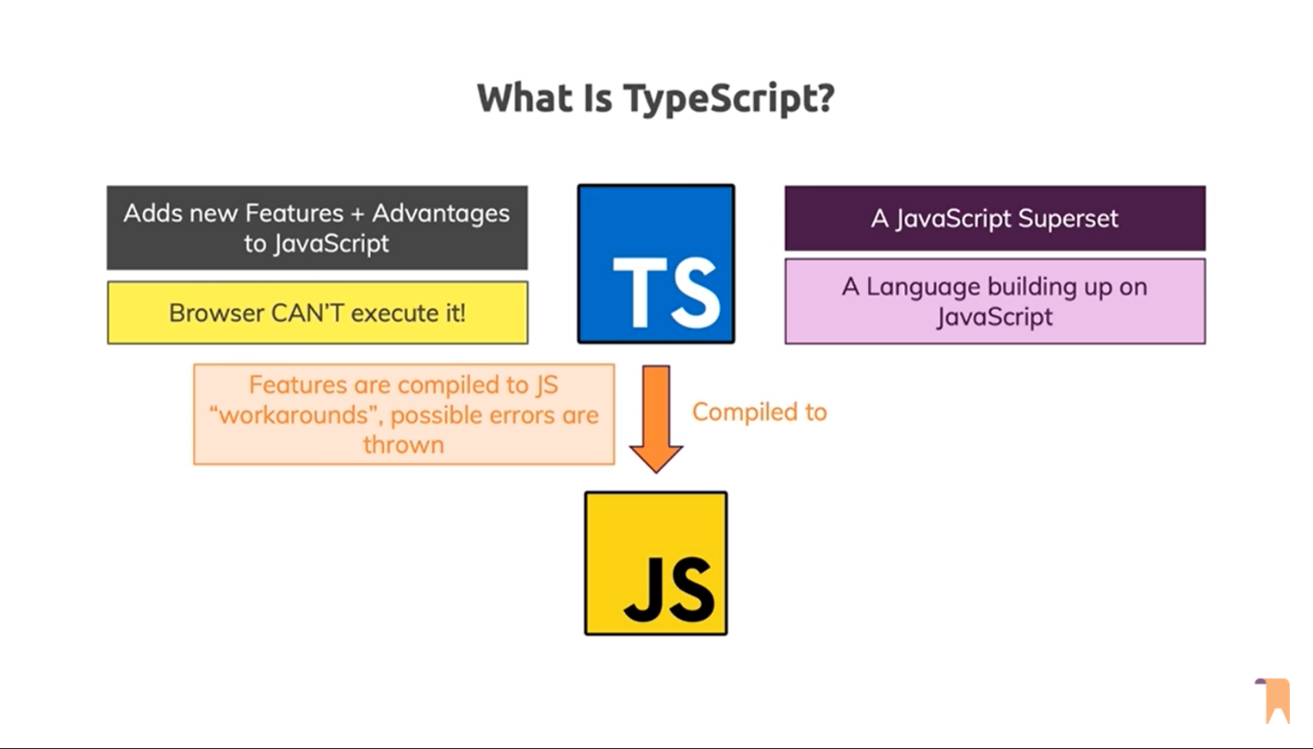

TypeScript is Typed JavaScript. TypeScript adds types to JavaScript

Nor node

.ts & .tsx is the extension for TypeScript

TypeScript is a programming language and a powerful compiler.

TSC (TypeScript Compiler) is used to compile TypeScript file(.ts) transpile to pure JS(.js).

**Pros**: More Robust | Easily spot Bugs | Predictability | Readability | Popular

**Cons**: More code to write | more to learn | required compilation | not true static typing

# Type Annotation

let name: string = 'John';

let age: number = 25;

let active: boolean = true;

compile: tsc <TS_Filename.ts> | tsc <TS_Filename>

To continuous monitor the changes tsc --watch <TS_Filename.ts>

tsc --init for configuration file

document.getElementByID(‘’)!;

! make sure it always returns a value and never be the null.